WEB PAGE

Collect web

The target in this web Will be the ordercollections and clientscan make by him self and add information
Philately its a hobby collect stamps.
A lot web for that but to simple or to complicate
https://colnect.com/es/stamps/list/country/169-Per%C3%BA
Too comlicate
http://www.stampsperu.com/peru2008.htm
too simple
https://www.stampworld.com/es/maps/Europe/
like this one
the order :

TYPEOF ADM: 1.- SUPERADMIN , 2.-ADMIN 3.- ASIST 4.- CLIENT 5.- NOT REGISTER

Here the structure of the web

1 Entrar / Registrarse
IDIOMA()
who we are Catálogue store (only for peru)
_____________________________________________________________________________

Some pic

VIDEO 1

Acounts (gráficos)(chart)(contador)

people
Total register
countrys

Registrado 2020 @ ……

**IDIOMA() ESPAÑOL , INGLES , PORTUGUES
Who we are

TEXTO

video

Dedicatoria

Back to inicio
Ingresar

email / Nick name :
password :
ok
Registrarse

name:
last name:
born:
Email:
country:
Phone :
nickname :
password :
Repet password :
collections
country() theme () CONDICION () TyPe()
A.-
B.-
C.-
D.-
MAS
CONFIRMAR POR MAIL
CONFIRMAR
**PAIS() ALL COUNTRY
**TEMATICA () ALL THEME
**CONDICION () NUEVO , MINTH , USADO , ANY
TIPO() SERIE , SOBRE , FDC , CUADRO , OTRO …. ESPECIFICAR :

Catálogos
Country themes

A B C X Y Z

=== ===

search: __________________ ENTER
((HERE YOU CAN FIND) IF IND CLICK AND SHOW IF CANT NEW CATALOGUE))

PERU
CLICK TOO LOOK

NEW CATALOGO

NEW CATALOGUE

TIPO ()COUNTRY, THEME
NAMEE :

ONLY THE SUPERADMIN CAN GIVE THE PERMITION TO MAKE IT

DONE

YOU JUST SEND A REQUEST TO SUPER ADMIN , YOU CAN LOOK YOUR FRONT PAGE WHEN SUPER ADMIN AGREE TO THIS CATEGORY

HERE THE SUPER ADMIN RECIVE THE ANK AND CAN GIVE THE PERMITION TO MAKE A NEW CATALOGUE

SUPER ADMIN CAN SAY YES OR NO

IF SAY NO , THE CLIENT RECIVE A CHAT
IF SAY YES GO TO THE NEW CATALOGUE CODE ()
NEW CATALOGUE

NEW CATALOGUE

IMPORT DATA BASE EXEL _________example.xls import

This person Will be a admin of this catalogue
The info Will make Will be this:

Group
Country :
Title:
Data from _____ to ______
Set : x souvenir sheet : y
Then open x time for set info :
This group open a windoes whit x set and y sheet
Facial : ()coin (i want when person put contry and year auto putt he coin
Size __ x ___ mm
Cat 1____ Price ___ ()
Cat 2____ Price ___ ()
Cat 3____ Price ___ ()
Themes ()
Name :
Pic:
Then open y time for sheet info :
Facial :
Size __ x ___ mm
Cat 1____ Price ___ ()
Cat 2____ Price ___ ()
Cat 3____ Price ___ ()
Themes ()
Name :
Pic:

ADD
Hello marcos IDIOMA()
WHO WE ARE ACATALOGUES exchange
_____________________________________________________________________________
My catalogue
Country themes
X y z A B C

Chat ,of especific catalogue

Registrado 2020 @ ……

** here we can see a the catalogue
2 type like web or like book
And i can coose which one 1 have or i need from data base

Exange

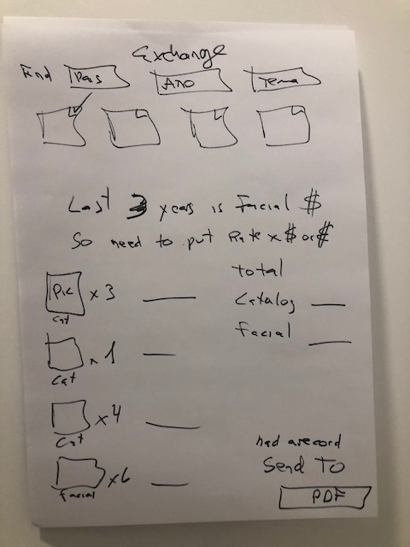

App

idea del app CAN MAKE LISTS , FILTERS
APP CAN RECONOCIDE PIC .

